EENG 385 - Electronic Devices and Circuits

BJT Curve Tracer: Calibration

Lab Document

**Objective**

The objective of the lab is to introduce the behavior of a transistor and how the how the BJT curve tracer draws the family of *Ic vs. Vce* curves on an oscilloscope in X/Y mode. Finally, we wil calibrate the BJT curve tracer in order to quantify the information displayed on the oscilloscope.

# Overview

Within the lab, you will complete the construction and calibration of the BJT curve tracer, a circuit using an oscilloscope in X/Y mode to display the family of curves shown in Figure 1 (right) for a BJT acting as the device under test (DUT) Figure 1 (left).

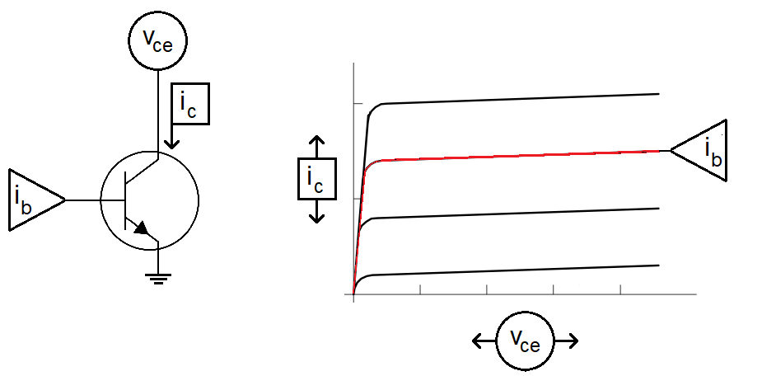

Figure 1: (Left) The signals needed to generate the characteristic family of curves for a BJT under test include Ib, the base current, Ic the collector current, and Vce the collector emitter voltage. (Right) The family of Ic vs. Vce curves as drawn on the oscilloscope.

To generate the red curve in Figure 1 (right), we need to complete the following 3 plotting tasks:

1. Set the base current to the red value in Figure 1 (right).
2. Then, sweep the collector emitter voltage from 0V to 5V.
3. Then, while doing the sweep, measure the collector current.

Fortunately, we have built most of the circuits needed to accomplish the task in the previous labs. These circuits interface with the DUT and the current mirror shown in Figure 2 to generate the signals shown in Figure 1.

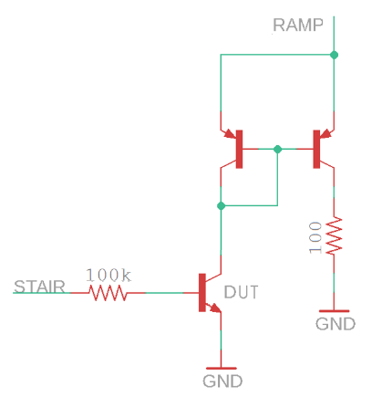

Figure 2: The output stage of the BJT curve tracer uses a current mirror to measure the collector current.

The list of plotting tasks is reframed in terms of the circuit shown in Figure 2 as:

1. The STAIR voltage is fed into the base of the DUT through a 100 kΩ resistor, setting the base current.
2. The collector emitter voltage of the DUT sweeps from 0V to 5V using the output of the pseudo ramp generator.
3. The collector current of the DUT is indirectly measured, through the current mirror, as the voltage across a 100 Ω resistor.

Now, a way to plot the collector emitter voltage against the collector current is needed. This need is where the X/Y mode of the oscilloscope comes into its own.

# Oscilloscope in X/Y Mode

You have mainly used oscilloscopes in time-base mode, meaning the voltage on Channel 1 is plotted vs. time. You can imagine the voltage on Channel 1 controls the height of the beam as the beam is being swept across the display. In X/Y mode, the oscilloscope uses the voltage on Channel 1 to control the horizontal position (x-axis) of the beam and, at the same time, uses the voltage on Channel 2 to control the vertical position (y-axis) of the beam.

At first, this interaction sounds really weird and counter intuitive. However, you can do some pretty useful things with an oscilloscope in X/Y mode, like drawing the family of curves for a BJT. To explore this idea further, let’s work the following example. Use the voltages on Channel 1 and 2 in Figure 3 to determine what is displayed with the oscilloscope is X/Y mode. In this example, the following conditions are set.

* Ch 1 is configured to provide x-axis data.
* Ch 2 is configured to provide y-axis data.
* The vertical axis for Ch1 and Ch2 is 1 Volt per division.
* The center horizontal line is set to 0V.

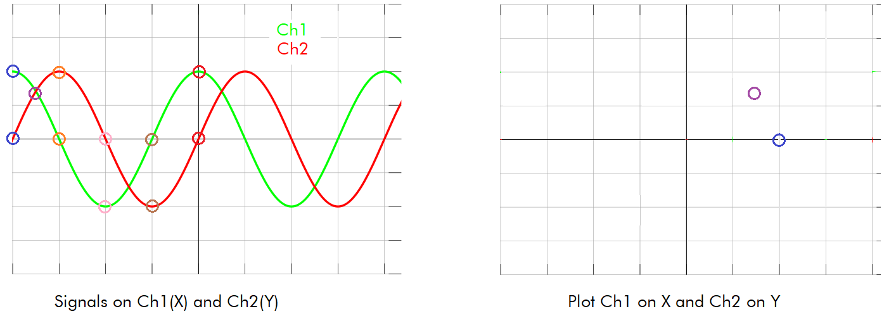

Figure 3: A pair of signals on Channel 1 and Channel 2. Plot these 2 signals in XY mode.

At the left edge of the screen, the values of Ch 1 and Ch 2 are circled in blue, with Ch 1=2V and Ch 2=0V. So in the right half of Figure 3, a blue circle is placed at (x,y) = (2V, 0V). Note, the X/Y plot has the same scale as its respective channel.

Complete Table 1 by finding the voltages for Channel 1 and Channel 2 at the indicated times. Then, place these points on the X/Y plot, connect the dots, and determine what the user would see. The key to determining the scales of the X- and Y-axis in Figure 4 is the circuit which drives the X and Y signals, shown in Figure 5.

Table 1: The X,Y values of the curve in Figure 3.

|  |  |  |
| --- | --- | --- |
| **Time** | **Ch 1 (X)** | **Ch 2 (Y)** |
| Blue | 2 | 0 |
| Purple | 1.4 | 1.4 |
| Orange | 0 | 2 |
| Pink | -2 | 0 |
| Brown | 0 | -2 |
| Red | 2 | 0 |

# Axis Scale for BJT Curve Tracer

We need a way to convert the picture shown on the oscilloscope into numerical data informing us of the operation of the BJT. You will quantify the picture on the oscilloscope using the grid displayed on the oscilloscope screen and by the scale settings you establish by turning the Ch 1 and Ch 2 vertical scale knobs. Some notation is in order before proceeding.

* Let *VSCALE_X* be the volts per division set with the Ch 1 Vertical scale knob. This number is shown after the yellow “1” in the upper left corner of the oscilloscope screen.
* Let *VSCALE_Y* be the volts per division set with the Ch 2 Vertical scale knob. This number is shown after the green “2” in the upper left corner of the oscilloscope screen.
* Call the distance between the grid lines shown on the oscilloscope face “divisions”.

For example, in Figure 4, *VSCALE_X* = 500 mV/div and *VSCALE_Y* = 200 mV/div. The X1 and X2 cursors are about 8.4 divisions apart.

* 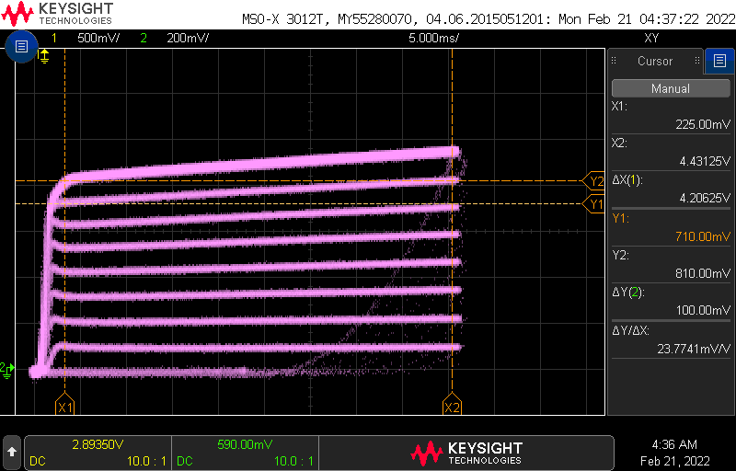

Figure 4: The oscilloscope display showing the family of curves.

The key to finding an equation allowing us to convert the picture on the oscilloscope screen to numerical values are the circuits which drive the X and Y signals shown in Figure 5.

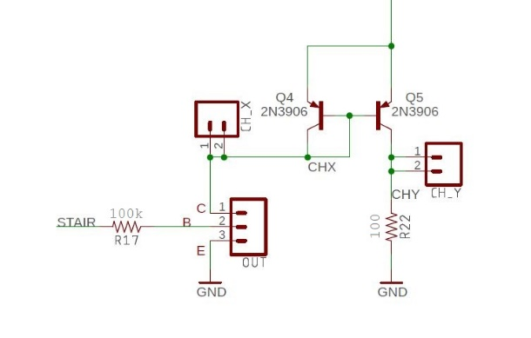

Figure 5: The circuit generating the 2-channels for the X-Y mode.

Let’s start by examining the Horizontal Axis scale.

**The Horizontal Axis Scale – Collector Emitter Voltage**

You will connect the Channel 1 of the oscilloscope to CH_X in Figure 5 and as a result probe to the collector of the DUT. Since the emitter of the DUT is at ground, CH_X is measuring *Vce* of the DUT. Thus, we have Equation 1:

|  |  |  |
| --- | --- | --- |
|  |  | 1 |

Now let’s focus on the collector current measured on Channel 2 of the oscilloscope.

**The Vertical Axis Scale – Collector Current**

You will connect the Channel 2 of the oscilloscope to CH_Y in Figure 5. Note that Q4 and Q5 are arranged as a current mirror, meaning the collector current out of Q4 is equal to the collector current out of Q5. Since the current out of Q4 is the collector current, ic, of the DUT then the current output of Q5 is also equal to *ic*. Thus, the collector current is equal to the current flowing through the 100Ω resistor. The voltage at the CH_Y probe in Figure 5 is found using Ohm’s law and given by Equation 2.

|  |  |  |
| --- | --- | --- |
|  |  | 2 |

Solving Equation 2 for the collector current is easy enough. The equality in Equation 4 is formed by replacing 100Ω with its Ohm’s law equivalent 10mA/V.

|  |  |  |
| --- | --- | --- |
|  |  | 3 |

**Putting it Together**

Let’s try to use the ideas just presented to determine Vce and ic of the points marked in Figure 6. Do this by first converting the position of the square into voltage. You need to know two things in order to perform this conversion.

* The x-axis is scaled at 1V/division and the y-axis is scaled at 0.2V/division.
* The 0V,0V is located at the red square (pointed at by the small yellow and blue arrows)

Now the orange square is located 1 division to the right of the red square, hence has an x-axis voltage of 1V. Thus, by Equation 1, Vce = 1V. The orange square is 4 divisions above the red square, hence has a y-axis voltage of 4division * 0.2V/division = 0.8V. Hence, by Equation 4, ic = 0.8V * 10mA/volt = 8mA.

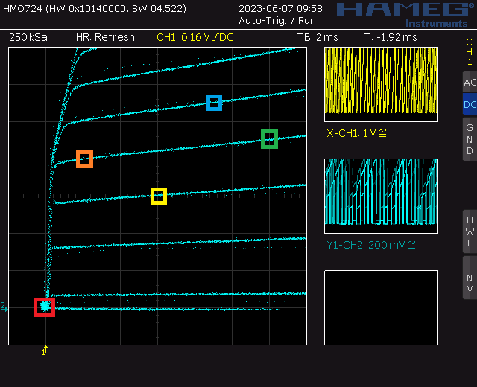

Figure 6: A family of curves with colored squares marking points to determine Vce and ic.

Table 2: Complete the table using the information in Figure 6.

|  |  |  |  |  |
| --- | --- | --- | --- | --- |
| Square | VCHX | Vce | VCHY | ic |
| Red | 0 | 0 | 0 V | 0 mA |
| Orange | 1V | 1V | 0.8V | 8mA |
| Yellow |  |  |  |  |
| Green |  |  |  |  |
| Blue |  |  |  |  |

**Each Curve – Base Current**

The circuit in Figure 5 keeps the DUT transistor in the active region. Thus, the BE junction of the DUT has a 0.7V drop. Since the emitter of the DUT is grounded, this arrangement means the base of the DUT is at 0.7V. Let’s call the voltage at the STAIR signal *VSTAIR*. You can use a combination of KVL and Ohm’s law to compute the voltage drop from *VSTAIR* to ground as:

|  |  |  |
| --- | --- | --- |
|  |  | 4 |

Solving Equation 4 for *ib* yields Equation 5.

|  |  |  |
| --- | --- | --- |
|  |  | 5 |

Computing the base current for each value of *VSTAIR* requires you to carefully measure the voltage of each step. Note, you can perform this measurement before soldering in the new components associated with this lab. To get these values, start by powering up your BJT curve tracer board with 9V from the lab power supplies. Next, power up an oscilloscope, attach a probe to Channel 1 and configure the oscilloscope as follows:

|  |  |
| --- | --- |
| Ch1 probe | STAIR test point |
| Ch1 ground clip | GND test point |
| Horizontal (scale) | 1ms |
| Ch1 (scale) | 1V or 2V (whatever fits better) |
| Trigger mode | Auto |
| Trigger source | Ch1 |
| Trigger slope | ↓ |
| Trigger level | 4.5V |

You should get something that looks like the curve in Figure 7.

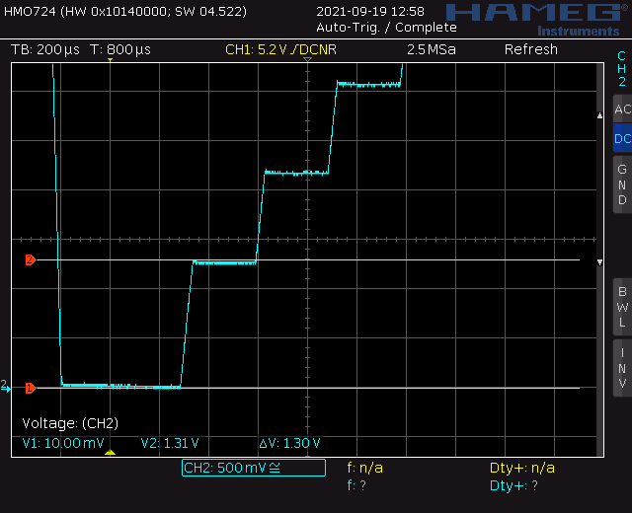

Figure 7: Measuring the voltage of the first VSTAIR value using cursors to be about 1.3V.

Now, measure the voltage of each step and record the values in the *VSTAIR* column of Table 3. Note, Trace 0 never leaves 0V. Trace 1 is the first trace above Trace 0 and should be around 1.3v. Your values will be different from those given in Table 3.

Table 3: The base current for each step of the staircase function. Yes the VSTAIR voltage are different from those shown in Figure 7.

|  |  |  |
| --- | --- | --- |
| **Trace** | ***VSTAIR* (V)** | ***ib* (µA)** |
| 8 | ---- | ---- |
| 7 | ---- | ---- |
| 6 | 7.6 | 15uA |
| 5 | 6.4 | 12uA |
| 4 | 5.1 | 9.4uA |
| 3 | 3.9 | 6.8uA |
| 2 | 2.6 | 4.0uA |
| 1 | 1.4 | 1.5uA |
| 0 | 0 | 0 |

Now, use the voltages in the ***VSTAIR*** column of Table 3 to compute the base current, ib, using Equation 5. You will need the information in Table 3 every time you run the BJT curve tracer with a DUT. Let’s explore how to use this information to calculate the gain and Early Voltage of the DUT.

# Completing the BJT Performance Card for a BJT

By completing the BJT performance card, you will be able to determine two important parameters of the BJT under test, the DC gain and the Early voltage. To determine these parameters, download and open the bjtPerformanceCard.docx Word document posted on Canvas. The document should look similar to Figure 11. Use the information from Table 3 to fill in the *ib* column in the table circled in red in Figure 11. While you are at it, fill in your name in the **Name** field and the identity of the BJT in the **Device ID** field. Since your BJT curve tracer is unique to you and the information in Table 3 will not change, you will save a personal copy of the bjtPerformanceCard document with this information typed in permanently.

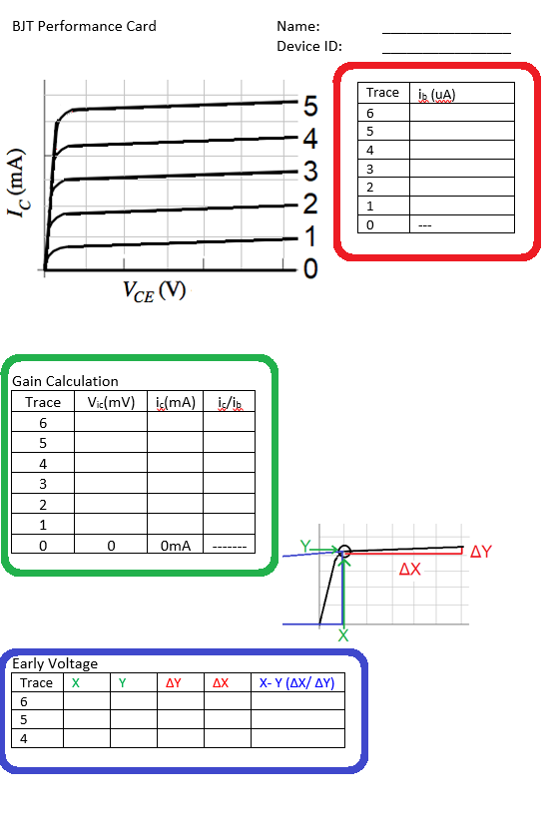

Figure 11: The BJT Performance card you will complete for every DUT. Text will be colored red, orange, or green when it describes how to fill in the BJT Performance Card table circled in that color.

By filling in this information, you have taken the first step in computing the Gain Calculation table outlined in green. Let us see what other information is need to collect and compute in order to complete the Gain Calculation table.

Start by powering the BJT Curve Tracer with 9V from a lab power supply. Next, you will need to setup your oscilloscope as shown in the following table. Note, you may need to adjust this configuration depending on the DUT.

|  |  |
| --- | --- |
| Horizontal (scale) | 5 ms |
| Ch1 probe | CH_X |
| Ch1 (scale) | 0.5V/div |
| Ch 1(position) | Lowest visible reticule |
| Ch2 probe | CH_Y |
| Ch2 (scale) | 0.2V/div |
| Ch 2(position) | Lowest visible reticule |
| Trigger mode | Auto |

Finally connect the test BJT to the DUT socket.

You should see a rather chaotic set of waveforms as those shown in Figure 12 with activity on both channels. If either channel has no signal, make sure the DUT is firmly inserted into the test fixture or check if the DUT is inserted backwards. (Some BJTs have the collector and emitter terminals swapped.) Adjust the ground reference of both channels to the lowest visible reticule.

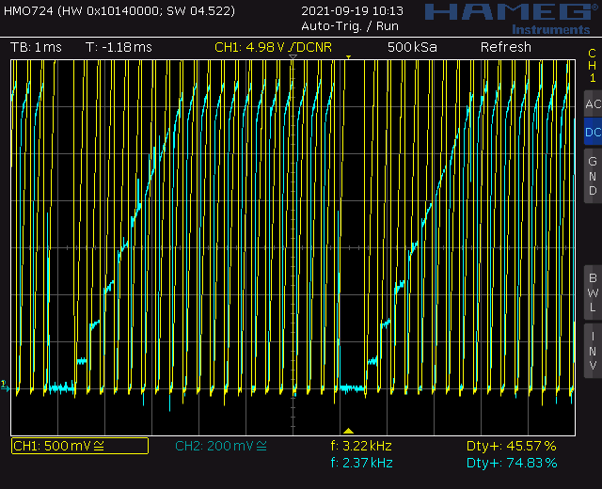

Figure 12: The oscilloscope output with a DUT in normal mode.

Next, you will need to put the oscilloscope into X/Y mode. Find the **Horiz** button and then use the softkey menu to select X/Y.

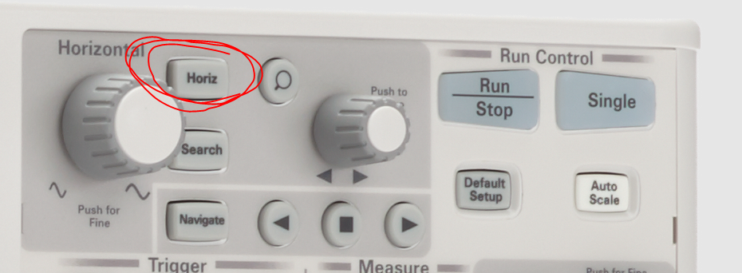

Figure 13: Display showing the placement of the Horiz button.

You may start out with an image that look like Figure 14.

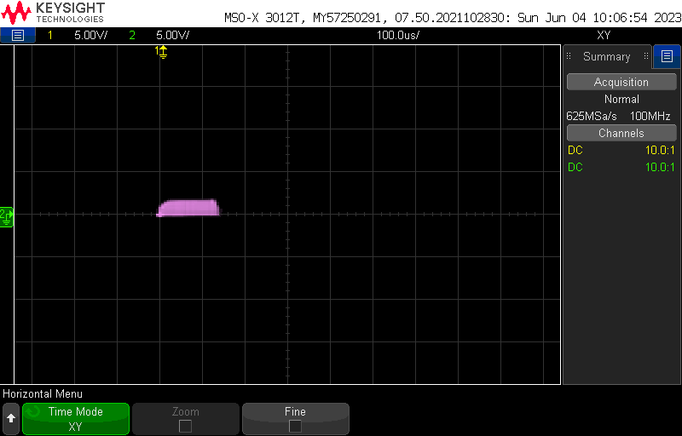

Figure 14: X-Y mode when first enabled. You need to adjust the voltage scale and offset to make the curves recognizable.

Use the Channel 1 and Channel 2 scale knobs on the oscilloscope to make the curves larger like that shown in Figure 15

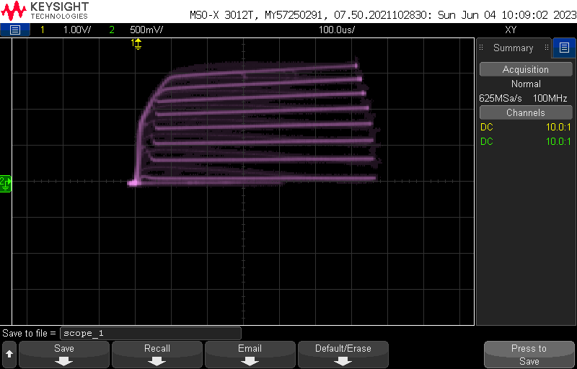

Figure 15: Use the Channel 1/2 scale knobs to change the width/height of the curves respectively.

Next use the Channel 1 and Channel 2 offset knobs to move the curves to the lower left corner of the display, while you are doing this, you can use the scale knobs to produce an image like that shown in Figure 16.

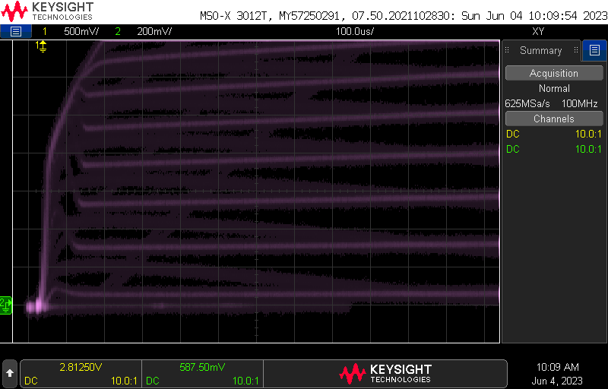

Figure 16: Use the Channel 1/2 offset knobs to move the curves horz/vert respectively.

You should adjust the horizontal scale to enhance the family of curves. You can experiment with the intensity (using the small button below the adjust knob) to tune your picture like that shown in Figure 17 (left). You can also try Acquire -> High Resolution Model to greatly sharpen the image at the expense of added noise on the display Figure 17 (right). Use whatever you prefer.

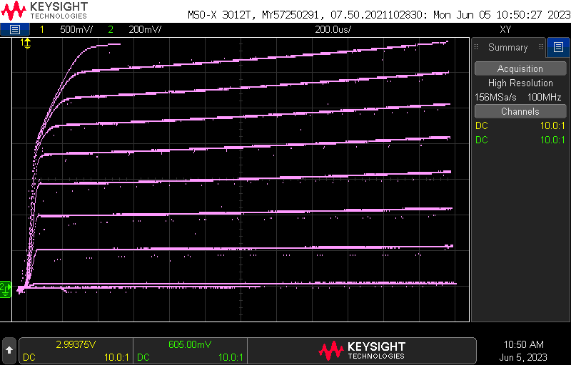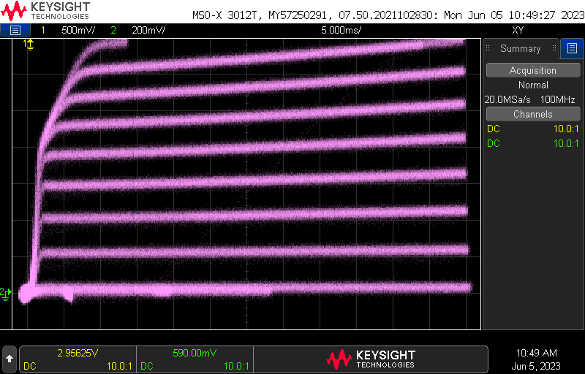

Figure 17: Use the intensity (left) or High Resolution Mode to sharpen the curves.

Congratulations, you have your BJT curve tracer working! Let’s figure out how to get numerical information from the plot to complete the Gain Calculation portion to the BJT Performance Card.

**Gain Calculation**

You will use the cursor function of the oscilloscope to measure the collector current and use this to determine the current gain.

You will need to measure the collector current for each curve at Vce = 1v. Start by enabling the cursor function by pressing the Cursor hard key. Pressing the Cursor soft key brings up a menu of the four cursors you can adjust. You can change the active cursor using the adjust knob (has a green illuminate circular arrow next to it). You can adjust the position of the active cursors using the Measure knob. Start by adjusting the X1 and Y1 cursors to 0v (look at the lower right area of the display to see the voltage of each cursor). Next adjust the X2 cursor to 1v; this makes the X2 cursor lie at Vce = 1V. Finally adjust the Y2 cursor to the intersection of the X2 cursor and the curve you whose collector current you want to measure.

Figure 18: Using the cursors to measure the collector current of the 3rd curve.

In Figure 18, the Y2 cursor is at 400mV. You will record this value in the Vic column of Table 3 in row 3 because this is the third curve in the family. You should keep the Y2 cursor selected and adjust its position using the Measurement knob. This will enable you to determine all the collector current voltages for the different curves. Note, feel free to change the vertical scale or offset to better position the curves for measurement.

When any of the following text is color-coded red or green, it refers to one of the circled areas in Figure 11. The data in this section will be a combination of the information contained in Figure 18 and the base currents found in Table 3. Your values will be different than those shown here.

1. Now, you need to fill in the green-circled area to determine the collector current for each of the curves. You will do this by recording the voltage of each curve as it passes Vce = 1V and put them into the Vic column. Use the cursor procedure discussed at the beginning of the section.

Table 4: The Gain Calculation table filled in using the information from Figure 18 and Table 3. These gains are unreasonably high and have too much variation.

|  |  |  |  |  |
| --- | --- | --- | --- | --- |
| **Trace** | **Vic**(mV) | ***ic***(mA) | ***ib***(uA) | ***ic / ib*** |
| 6 | 1.04 | 10 | 15uA | 666 |
| 5 | 0.9 | 9.0 | 12uA | 750 |
| 4 | 0.72 | 7.2 | 9.4uA | 766 |
| 3 | 0.56 | 5.6 | 6.8uA | 824 |
| 2 | 0.4 | 4 | 4.0uA | 1000 |
| 1 | 0.2 | 2 | 1.5uA | 1333 |
| 0 | 0 | 0 | 0 | 0 |

1. Fill in the collector current column, *ic,* by multiplying the entries in the **Vic** column by the channel 2 conversion factor of 10mA/V Round your answers to 2 significant figures.
2. Copy the base currents from Table 3 into the ib column.
3. Finally, fill in the *ic / ib* column, the gain of the DUT, by dividing each collector current by its associated base current. Make sure you account for the change in units; mA for the collector current and uA for the base current.

Congratulations, you have calculated the gain of your DUT! You will get different gain values for different base currents. Asking for a single value of gain across a variety of base currents is pointless because the gain of a BJT has a weak dependence on the collector current. You can look in a BJT datasheet and verify this for yourself. So, we have to be satisfied with the values in our Gain Calculation table even if the values change with base/collector current.

**Early Voltage**

The Early voltage is the projection of the almost-horizontal portion of the characteristic curve will intersect the horizontal axis, the Early voltage. In the black curve in Figure 19 is one of the characteristic curves for the BJT displayed on the oscilloscope. The hypotenuse of the blue triangle is the projection of the sloped horizontal portion of the characteristic curve. The horizontal axis is the collector emitter voltage and consequently has the units of volts. The point where the hypotenuse of the blue triangle intersects the horizontal axis is the Early voltage. Early voltages are always negative.

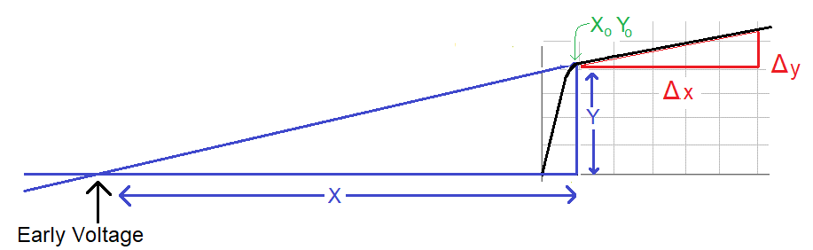

Figure 19: Calculating the Early voltage requires working with the red and blue similar triangles.

The red and blue triangles in Figure 19 have the same interior angles and as a consequence are similar. This means that the ratio of their bases and heights are equal. In other words.

which we can solve for X and get The Early voltage is equal to X shifted right by Xo. This gives us the final equation for the Early voltage in terms of the data gather from the oscilloscope using the cursor function.

You will measure the Early voltage using cursor function of the oscilloscope as follows. Like before, enable the cursor function by pressing the Cursor hard key. Set the X1 cursor to 1V, the X2 cursor to 5V (or the biggest integer voltage that will fit on your screen). Set the Y1 cursor to the intersection of the X1 cursor and the curve whose Early voltage you want to measure. Finally set the Y2 cursor to the intersection of the X2 cursor and the curve whose Early voltage you want to measure.

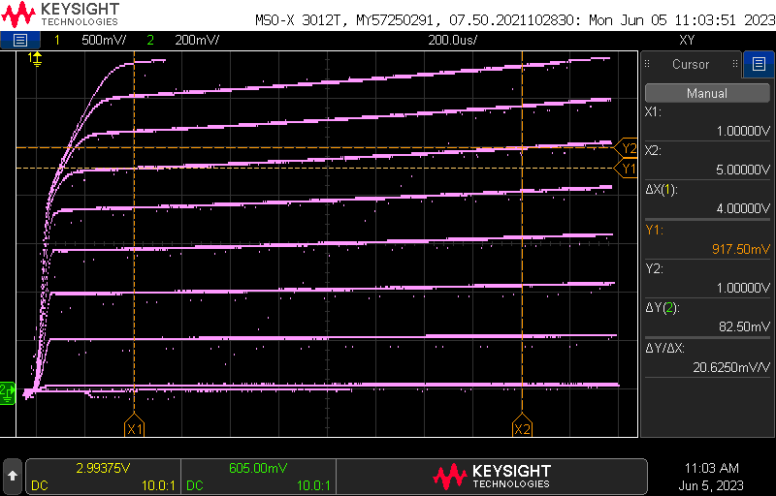

Figure 20: Measuring the Early voltage of the 6th curve using the cursors.

The right side of the screen provides all the information that you will need to fill in the information in Table 4. To take the remaining measurements, leave the X1 and X2 cursors, and adjust the Y1 and Y2 cursors to measure the slope of the remaining curves. As before, you may want to use change the vertical offset to move the curves and make to see them

We will examine Trace #6 in Figure 20 to explain how you will compute the Early voltage for your DUT. In the active region, Trace #6 is a straight line sloping upwards. Use the cursor function and align the X1 and Y1 cursors at the left end of the active region, where the curve is flat. Next align the X2 and Y2 cursors on the right end of the active region. You can use the X1 and X2 flags at the bottom of the screen and the Y1, Y2 flags on the right side of the screen to interpret the values shown on the right-side menu of the oscilloscope display.

Table 5: The Ealy Voltage table partially filled in using the data from Figure 20.

|  |  |  |  |  |  |
| --- | --- | --- | --- | --- | --- |
| **Trace** | **X1** | **Y1** | **ΔY** | **ΔX** | **X-Y (ΔX/ ΔY)** |
| 8 | 1 | 1.22 | 0.123 | 4 |  |
| 7 | 1 | 1.08 |  | 4 | -40 |
| 6 | 1 |  | 0.083 | 4 | -43 |

The Early Voltage is given by the value in the **X-Y (ΔX/ ΔY)** column. The data for the 7th and 8th curves is provided so that you have a sense of the expected variation in this measurement.

# Turn In:

Make a record of your response to numbered items below and turn them in to Canvas using the instructions posted there. While you can work together to answer the questions in this lab document, this is an individual assignment. Thus, everyone is expected to turn in their own document.

**Oscilloscope in X/Y Mode**

Completed Figure 3.

Completed Table 1.

**Axis Scale for BJT Curve Tracer**

Completed Table 2.

Completed Table 3 using data from your BJT curve tracer

**Completing the BJT Performance Card for a BJT**

Completed Table 4.

Completed Table 5.

Complete a BJT Performance Card for the 2N3904 BJT in a TO-92 package.

* + Determine the pinout for the Base, Emitter, and Collector from an online datasheet.

Complete a BJT Performance Card for the 2N2222 BJT in a TO-92 package.

* + Determine the pinout for the Base, Emitter, and Collector from an online datasheet.

Complete a BJT Performance Card for the BD139 in a TO-126 package.

* + Determine the pinout for the Base, Emitter, and Collector from an online datasheet.